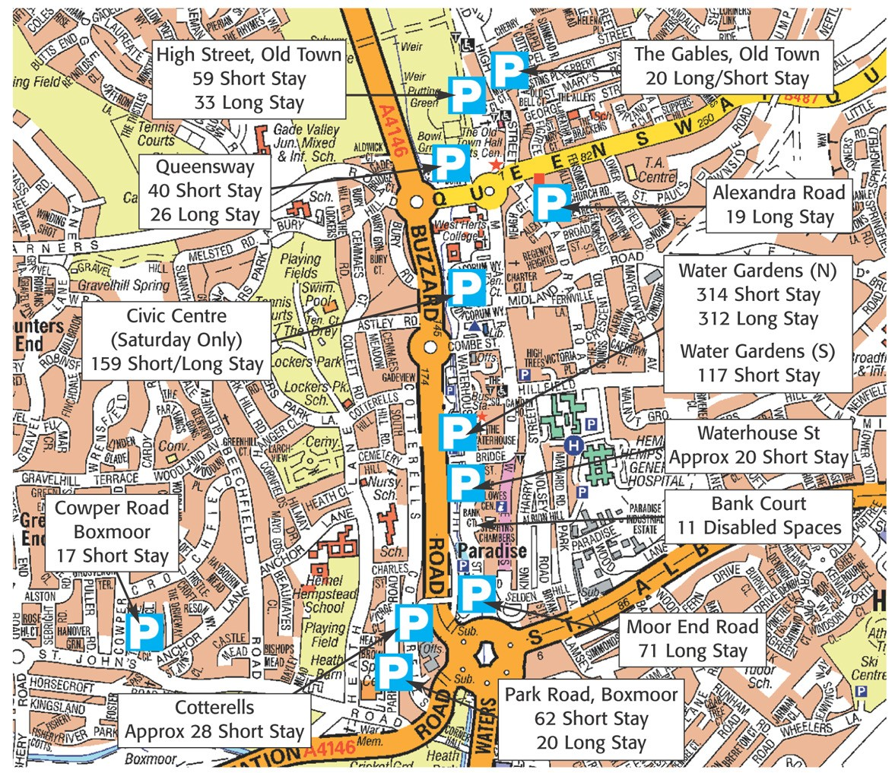NB NCP car park also available opposite the Postgraduate Centre on Hillfield Road, daily tariff £5.60

